
CASE STUDY EXECUTION REPORT
Department | FED
Subject | DSA-2
Academic Year | I-III Semester(2025-26)
Faculty Name | Dr. Sukanya ledella
Student Name | C.V JASWANTHREDDY
Roll Number | 2520080025
Branch | AI&DS
Course Outcome | CO-3

Case Study Topic: IRCTC Railway-Station Network
Work Done Summary: The IRCTC Railway Station Network uses a graph-based approach with Breadth First Search (BFS) to find the minimum number of train changes between two stations. Each station is stored as a node and every direct train connection is stored as an undirected edge.

Implementation Details:
Each node (Station) stores:
- Station Code
- Connected Stations List
- Visited Status
- Parent Station (for path tracking)
Operations:
- Insert Edge : Add direct train connection between stations
- Search (BFS) : Find minimum train changes between stations
- Queue Process : Visit stations level-by-level
- Path Tracking : Store route from source to destination
- Traversal : Display railway network connections

Result:
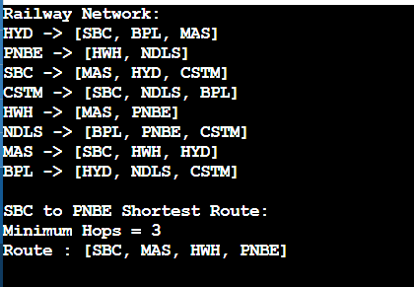
GitHub Link: https://github.com/challajaswanthreddy09-cell/DSA_2-Co-3
Student Signature | Faculty Signature

